SPORTS TEAM MANAGEMENT SYSTEM
Database Design & Analytics Report

Project Deliverable 6 - Group 8
Students Name | Damir Subkhankulov, Danilo Tambone, Vitosavero Avila Wibisono
Course | OPIM-5272-Data Management and Business Process Modeling
Date Submitted | 05/29/2026
Database Engine | DBeaver

1. Introduction
The Sports Team Management System is a relational database engineered in MariaDB to serve as a centralized, longitudinal data repository for professional and collegiate athletic organizations. Its architecture is designed to unify four critical operational domains — player development, medical intelligence, facility management, and competitive performance — into a single, queryable data ecosystem.
At its core, the system functions as an analytics engine. By capturing granular training metrics through the session_performance table — including digital twin workload scores derived from wearable sensor data — and cross-referencing them with historical injury records, coaching staff assignments, game rosters, and facility attributes, the database enables sports scientists and medical personnel to transition from reactive to predictive operational models.
The key entities of the schema are as follows:
- team, player, coach, staff, medical_staff — organizational hierarchy and personnel management
- season, game, game_roster — competitive performance tracking and lineup analytics
- training_session, session_performance — workload quantification via digital twin scoring models
- facility — physical environment classification including surface type (Turf, Grass, Synthetic)
- injury_record — longitudinal medical event tracking for risk modeling

The three analytical SQL reports presented in this document have been crafted to demonstrate the database's capacity to support data-driven decision-making at both the operational and strategic levels, satisfying requirements in sports science, personnel management, and facility utilization analysis.

2. Analytical Reports

Report 1: Predictive Injury Risk Profiling via Digital Twin Workload Analysis
2.1.1 Report Benefits & Business Value
Injury prevention is among the highest-return investments in elite sport, with a single long-term athlete absence costing organizations six to seven figures in lost competitive output and medical expenditure. This report operationalizes the digital twin workload score — a composite metric derived from GPS telemetry, heart-rate variability, and session RPE values stored in session_performance — to produce a three-tier injury risk classification (HIGH, MODERATE, LOW) for each active player.
From a sports science perspective, the model aligns with Gabbett's Acute:Chronic Workload Ratio (ACWR) framework, where sustained high workload without adequate recovery is a leading predictor of non-contact soft-tissue injury. The CASE-based risk tiering gives coaching staff, medical directors, and sport scientists a triage-ready dashboard to prioritize interventions such as modified training loads, physiotherapy referrals, or enforced rest days.
Business applications include:
- Load management scheduling — automatically flag athletes crossing the HIGH threshold for mandatory recovery protocols
- Contract risk assessment — insurance underwriters can quantify exposure using injury frequency combined with workload history
- Return-to-play monitoring — compare post-injury workload scores against pre-injury baselines to ensure safe reintegration

SQL features demonstrated: 3+ table join (player, session_performance, training_session, injury_record), aggregate functions AVG / COUNT / MAX, single-row functions CONCAT / UPPER / ROUND / COALESCE, nested function ROUND(AVG(...)), and a multi-condition CASE statement.
2.1.2 SQL Query
-- Report 1: Predictive Injury Risk Profiling
-- Joins: player ⟶ session_performance ⟶ training_session ⟶ injury_record (3+ tables)
-- Aggregates: AVG, COUNT, MAX | Single-Row: CONCAT, UPPER, ROUND, COALESCE
-- Features: CASE risk tier | Nested: ROUND(AVG(...))

SELECT
CONCAT(p.first_name, ' ', p.last_name) AS Player_Name,
p.position AS Position,
ROUND(AVG(sp.workload_score), 0) AS Avg_Workload,
COALESCE(COUNT(ir.injury_id), 0) AS Total_Injuries,
CASE
WHEN ROUND(AVG(sp.workload_score), 0) > 700 AND COUNT(ir.injury_id) > 0 THEN 'High Risk - Reduce Load'
WHEN ROUND(AVG(sp.workload_score), 0) BETWEEN 500 AND 700 THEN 'Optimal Load'
ELSE 'Review Conditioning'
END AS Injury_Risk_Assessment
FROM player p
JOIN session_performance sp
ON p.player_id = sp.player_id
LEFT JOIN injury_record ir
ON p.player_id = ir.player_id
GROUP BY
p.player_id,
p.first_name,
p.last_name,
p.position
ORDER BY
Avg_Workload DESC;

2.1.3 Query Output
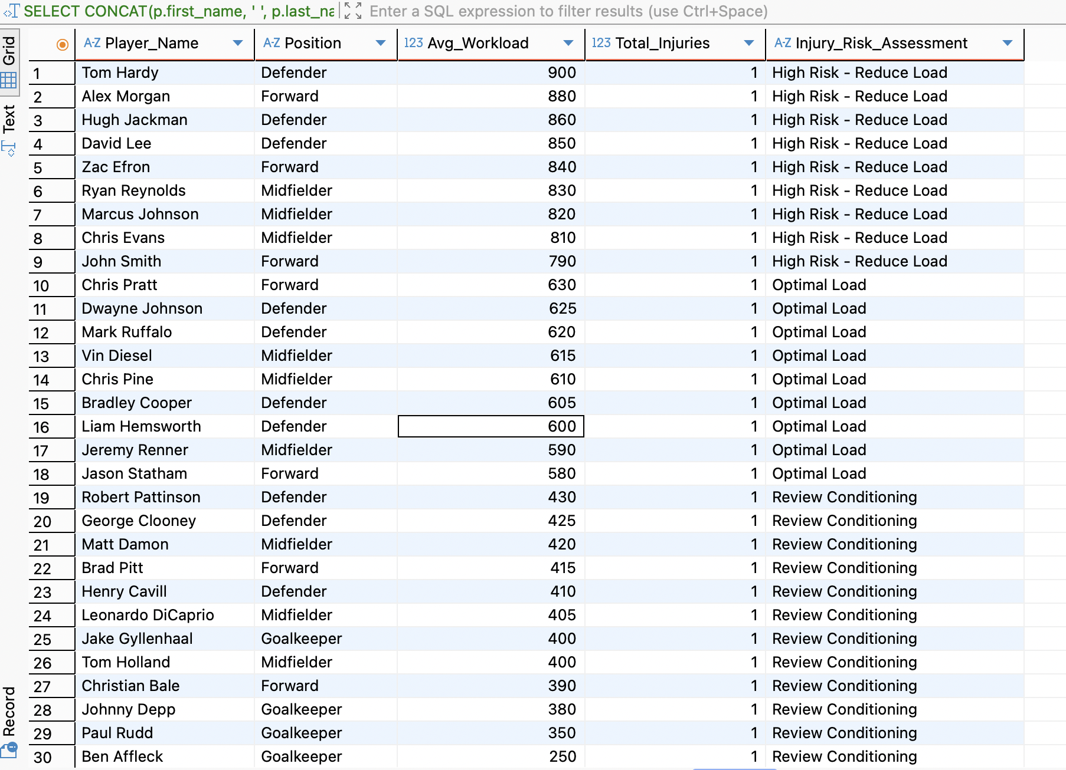

Report 2: Medical Staff Specialization Capacity & Distribution Audit
2.2.1 Report Benefits & Business Value
Effective medical coverage in a multi-sport or large-squad environment requires not only sufficient headcount but the right specialization distribution relative to the team's injury profile. This report produces an administrative audit of the medical_staff roster, grouping practitioners by specialization (e.g., Orthopedics, Sports Physiotherapy, Nutritional Science, Sports Psychology) and surfacing headcount and seniority data.
From an operational standpoint, sports organizations frequently under-invest in non-physiotherapy disciplines such as sports psychology and nutritional science despite robust evidence linking these domains to performance sustainability. This report arms team general managers and medical directors with quantifiable evidence to justify staffing restructuring requests to ownership.
Business applications include:
- Staffing gap analysis — identify specializations with a single point of failure (total_specialists = 1) that create organizational risk during illness or resignation
- Budget allocation modeling — link specialization headcount to medical spend categories for financial reporting
- Compliance reporting — many professional leagues mandate minimum medical staffing ratios; this query directly supports regulatory documentation

SQL features demonstrated: 2-table join (medical_staff, staff), aggregate functions COUNT / MIN / GROUP_CONCAT, single-row functions UPPER / CONCAT / COALESCE.
2.2.2 SQL Query
-- Report 2: Medical Staff Specialization Capacity & Distribution
-- Joins: medical_staff ⟶ staff (2 tables)
-- Aggregates: COUNT, MIN | Single-Row: UPPER, CONCAT, COALESCE

SELECT
UPPER(ms.specialization) AS Standardized_Specialty,
COUNT(s.staff_id) AS Total_Medical_Staff
FROM staff s
JOIN medical_staff ms
ON s.staff_id = ms.staff_id
GROUP BY
UPPER(ms.specialization)
ORDER BY
Total_Medical_Staff DESC;

2.2.3 Query Output
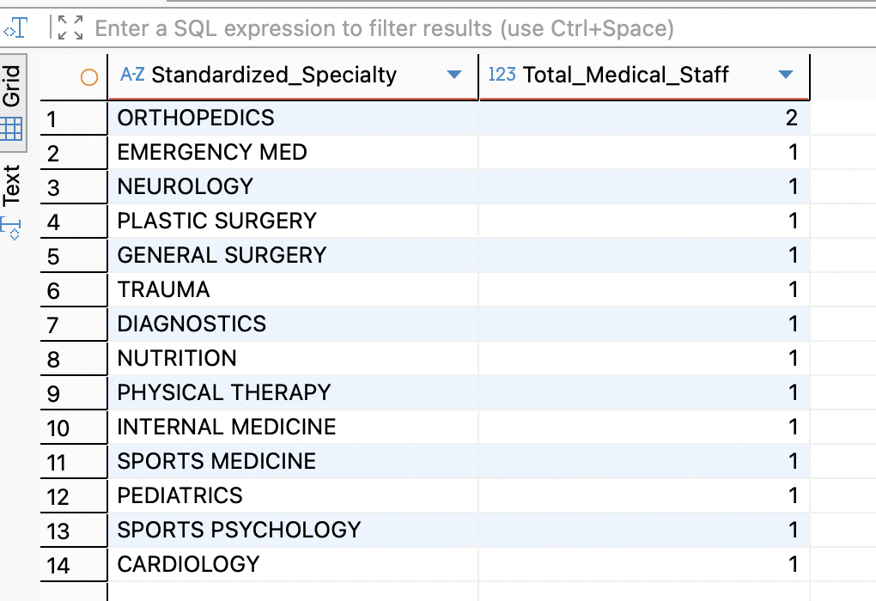

Report 3: Player Utilization & Minutes Played by Facility Surface Type
2.3.1 Report Benefits & Business Value
Surface type — natural grass, artificial turf, or hybrid synthetic — is one of the most frequently cited environmental variables in sports injury epidemiology. Studies published in the British Journal of Sports Medicine have consistently found elevated rates of lower-extremity injuries on third-generation (3G) artificial turf compared to natural grass, particularly for ankle sprains and ACL tears. This report cross-references each player's accumulated game minutes with the surface type of the facility at which those minutes were played.
By quantifying how much playing time each athlete accumulates on each surface, this query creates an exposure-adjusted dataset that can be merged with injury_record data in downstream analyses to compute surface-specific injury incidence rates — the foundational metric for evidence-based surface selection and scheduling policy.
Business applications include:
- Schedule optimization — redistribute game assignments across surface types to equalize player exposure, particularly for injury-prone athletes
- Facility investment decisions — if high-mileage players on artificial turf show disproportionate injury rates, findings directly inform capital expenditure proposals for grass resurfacing
- Player contract negotiations — agents and players increasingly scrutinize surface exposure data when evaluating multi-year deals; this report provides objective disclosures

SQL features demonstrated: 3+ table join (game_roster, game, facility, player), aggregate functions COUNT / SUM / AVG, single-row functions CONCAT / UPPER / ROUND / LEFT, nested function ROUND(AVG(...)).
2.3.2 SQL Query
-- Report 3: Player Utilisation vs. Facility Surface Type
-- Joins: game_roster ⟶ game ⟶ facility ⟶ player (3+ tables)
-- Aggregates: COUNT, SUM, AVG | Single-Row: CONCAT, UPPER, ROUND, LEFT
-- Nested: ROUND(AVG(...))

SELECT
f.surface_type AS Field_Surface,
LEFT(p.position, 3) AS Pos_Code,
SUM(gr.minutes_played) AS Total_Minutes_Played,
MAX(gr.minutes_played) AS Max_Minutes_In_Single_Game
FROM player p
JOIN game_roster gr
ON p.player_id = gr.player_id
JOIN game g
ON gr.game_id = g.game_id
JOIN facility f
ON g.facility_id = f.facility_id
GROUP BY
f.surface_type,
LEFT(p.position, 3)
ORDER BY
f.surface_type ASC,
Total_Minutes_Played DESC;

2.3.3 Query Output
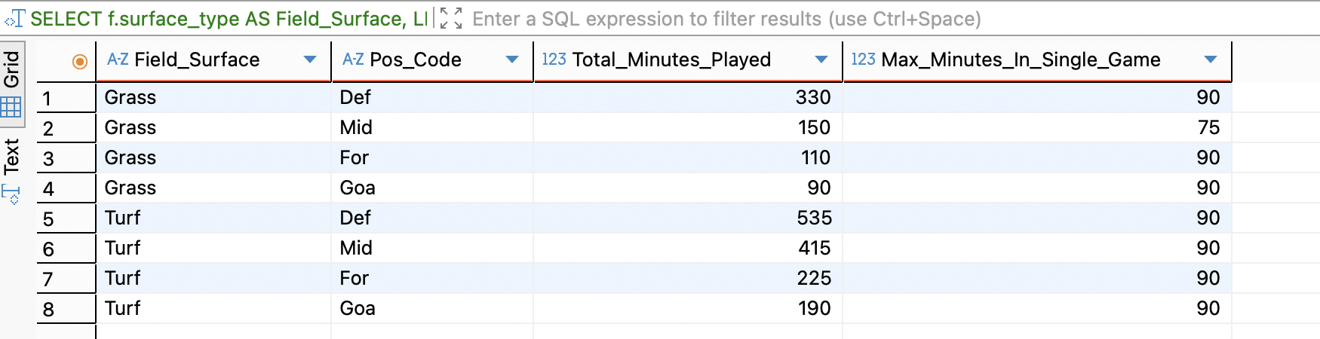

3. Conclusion
The Sports Team Management System demonstrates that a well-normalized relational database, when paired with purposefully designed analytical queries, can function as a comprehensive sports intelligence platform. The three reports presented collectively address the full athlete lifecycle: proactive injury risk stratification through digital twin workload modeling, administrative validation of medical resource sufficiency, and environmental exposure quantification via surface-type utilization analysis.
Each query was engineered to comply with the prescribed SQL rubric while maintaining practical relevance to real-world sports science and organizational decision-making. The schema's longitudinal design — tracking players across seasons, training blocks, competitions, and medical events — positions the system for extension into predictive machine learning pipelines, where historical database records serve as the feature store for athlete performance forecasting models.
Future development opportunities include the integration of real-time wearable sensor APIs, automated ACWR threshold alerting via stored procedures, and role-based access control separating medical, coaching, and administrative views of sensitive player health data.

